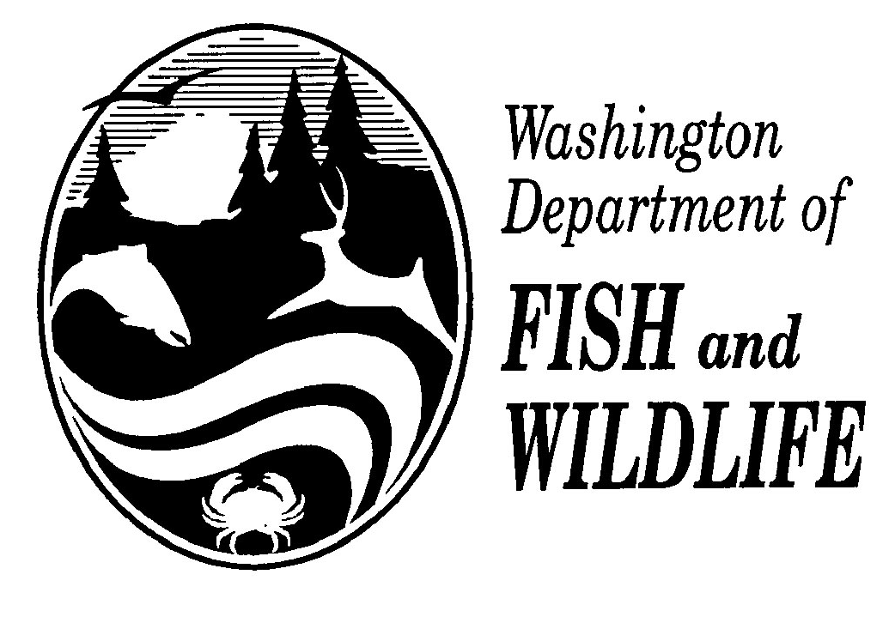
AQUATIC INVASIVE SPECIES WATERCRAFT ATTESTION
(To be completed by contest participants using boats only)

Contact/Sponsor:____________________________________________________________ Date:______________________

Water: ____________________________________________________________________ Permit#____________________

By filling out and signing this form, you are attesting under penalty of perjury and all applicable WA state laws that the boat, trailer, engine, or any water containers that you will use during this fishing contest has not been in physical contact with any waters outside of Washington, Idaho or Oregon State in the last 30 days.

 | Print Full Name | Home Location  City / State | Phone # | Signature | Date
1
2
3
4
5
6
7
8
9
10

I hereby certify that the following individuals are known to me and have provided correct information to the best of my knowledge.

Contest Director/Designee: _________________________________________________________ Date: ____________________________

NOTE to Contest Director: Attach and return this statement with final contest report due within 30 days of contest completion to Bruce Baker – Fish Management/Inland Fish Program.

Page _____ of _____

